22nd Annual ADHD and Related Concerns Conference
PROGRAM ADDENDUM
Additional Breakout Session Summaries

Neurodiverse & Thriving: Inclusive Strategies for Students with Autism & ADHD
-Sarieta Holmes-Pollard, PhD

This session provides all educators with evidence-based tools to support students with ADHD and autism in inclusive classrooms. It offers actionable strategies for academic, behavioral, and social-emotional success, with a focus on real-world classroom practices. Participants will leave with a deeper understanding of neurodiversity and practical approaches to unlock every learner’s potential.

Move to Learn – Let’s MOVE to LEARN
- Larry Calhoun, MS
- Kayleigh Hudson, MS

Better grades. Better health. That’s what Move to Learn is about. Studies have shown that physical activity increases children’s ability to learn. Move to Learn is a free web-based resource designed to be fun for students, improve learning, increase student focus, and assist teachers with classroom management.

Unlocking Potential: Innovative Therapeutic Strategies for Late-Diagnosed Dyslexic Students
-Kayla Reggio, MEd, CALT-QI, LDT
-Lauren Houston, EdS, CALT-QI, LDT

Lauren Houston will be facilitating this session along with Kayla Reggio in place of Traci Barrientos, MEd, CALT-Q.
THANK YOU to our Additional ALLY SPONSORS!  
Exhibitors

Collegium Pharmaceuticals
DuBard School for Language Disorders
Knox Academy
Learning Forward MS

Thank you to our additional exhibitors!
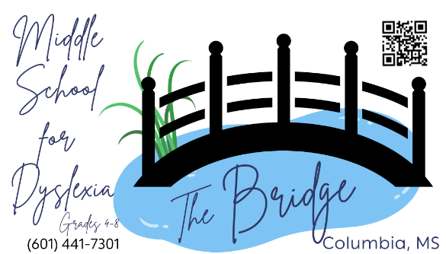

Additional Presenter Biographies

Natalie Briethaupt, BS
Natalie Breithaupt works at Kids First Education, LLC fulfilling Head Coach and coaching duties for MS. Her background includes years as an MDE Digital Learning Regional Coordinator in addition to an MDE K-3 Literacy Coach after spending 11 years as a classroom teacher and interventionist both at the school level and with the Barksdale Reading Institute. She has had the opportunity to implement several different coaching models throughout the years and has found that at the heart of each lies building positive, respectful, and collaborative relationships that allows for deep reflection and in turn educator and student growth.

Sarieta Holmes – Pollard, PhD
Dr. Sarieta Holmes-Pollard, a distinguished leader in special education, brings over 26 years of experience as an educator, director of disabilities, trainer, and author. Serving the Mississippi Department of Education, University of Mississippi, and Mississippi State University, she advances inclusive practices, classroom management, and behavior intervention through her organization, EmpowerED Learning- Special Education.

Lauren Houston, EdS, CALT-QI, LDT
Lauren Houston, a dyslexic herself, is from Hattiesburg, MS. She received her undergraduate degree in Elementary Education from William Carey University in May of 2014. Lauren began her Master’s Degree in dyslexia therapy while working for The 3D School, Dynamic Dyslexia Design in Petal, MS and graduated from William Carey University in May of 2017. She earned a Specialist Degree in Educational Leadership at William Carey University in 2021. Lauren is a Certified Academic Language Therapist & Qualified Instructor (CALT-QI) and resides in D’Iberville with her husband Blake, daughter Henley Grace, and son Hatcher.

